Practical - 8
Practical Title: MySQL Schema Design, ER Model, PDO Connectivity, and Prepared Statements
Problem Definition: Design the database for StudentHub with students, events and registrations. Create PHP database connection using MYSQL statements.

Theory :
1. Is the schema normalized properly?

Yes. The StudentHub schema is properly normalized up to 3NF.

2. Are primary keys and foreign keys correctly defined?

Yes, the primary keys and foreign keys are correctly defined.

3. Is the database connection handled securely?

Yes, the database connection is handled securely for the project.

Data:
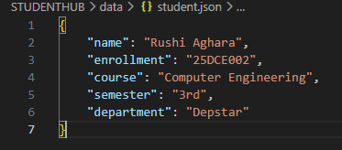
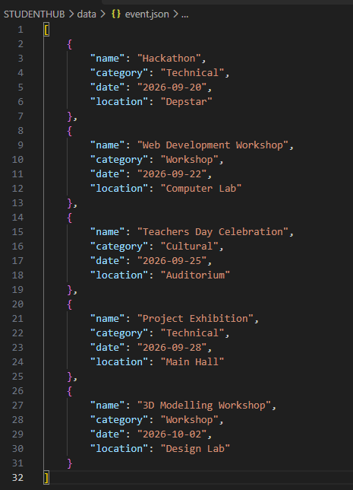

Implementation/ Output/Result
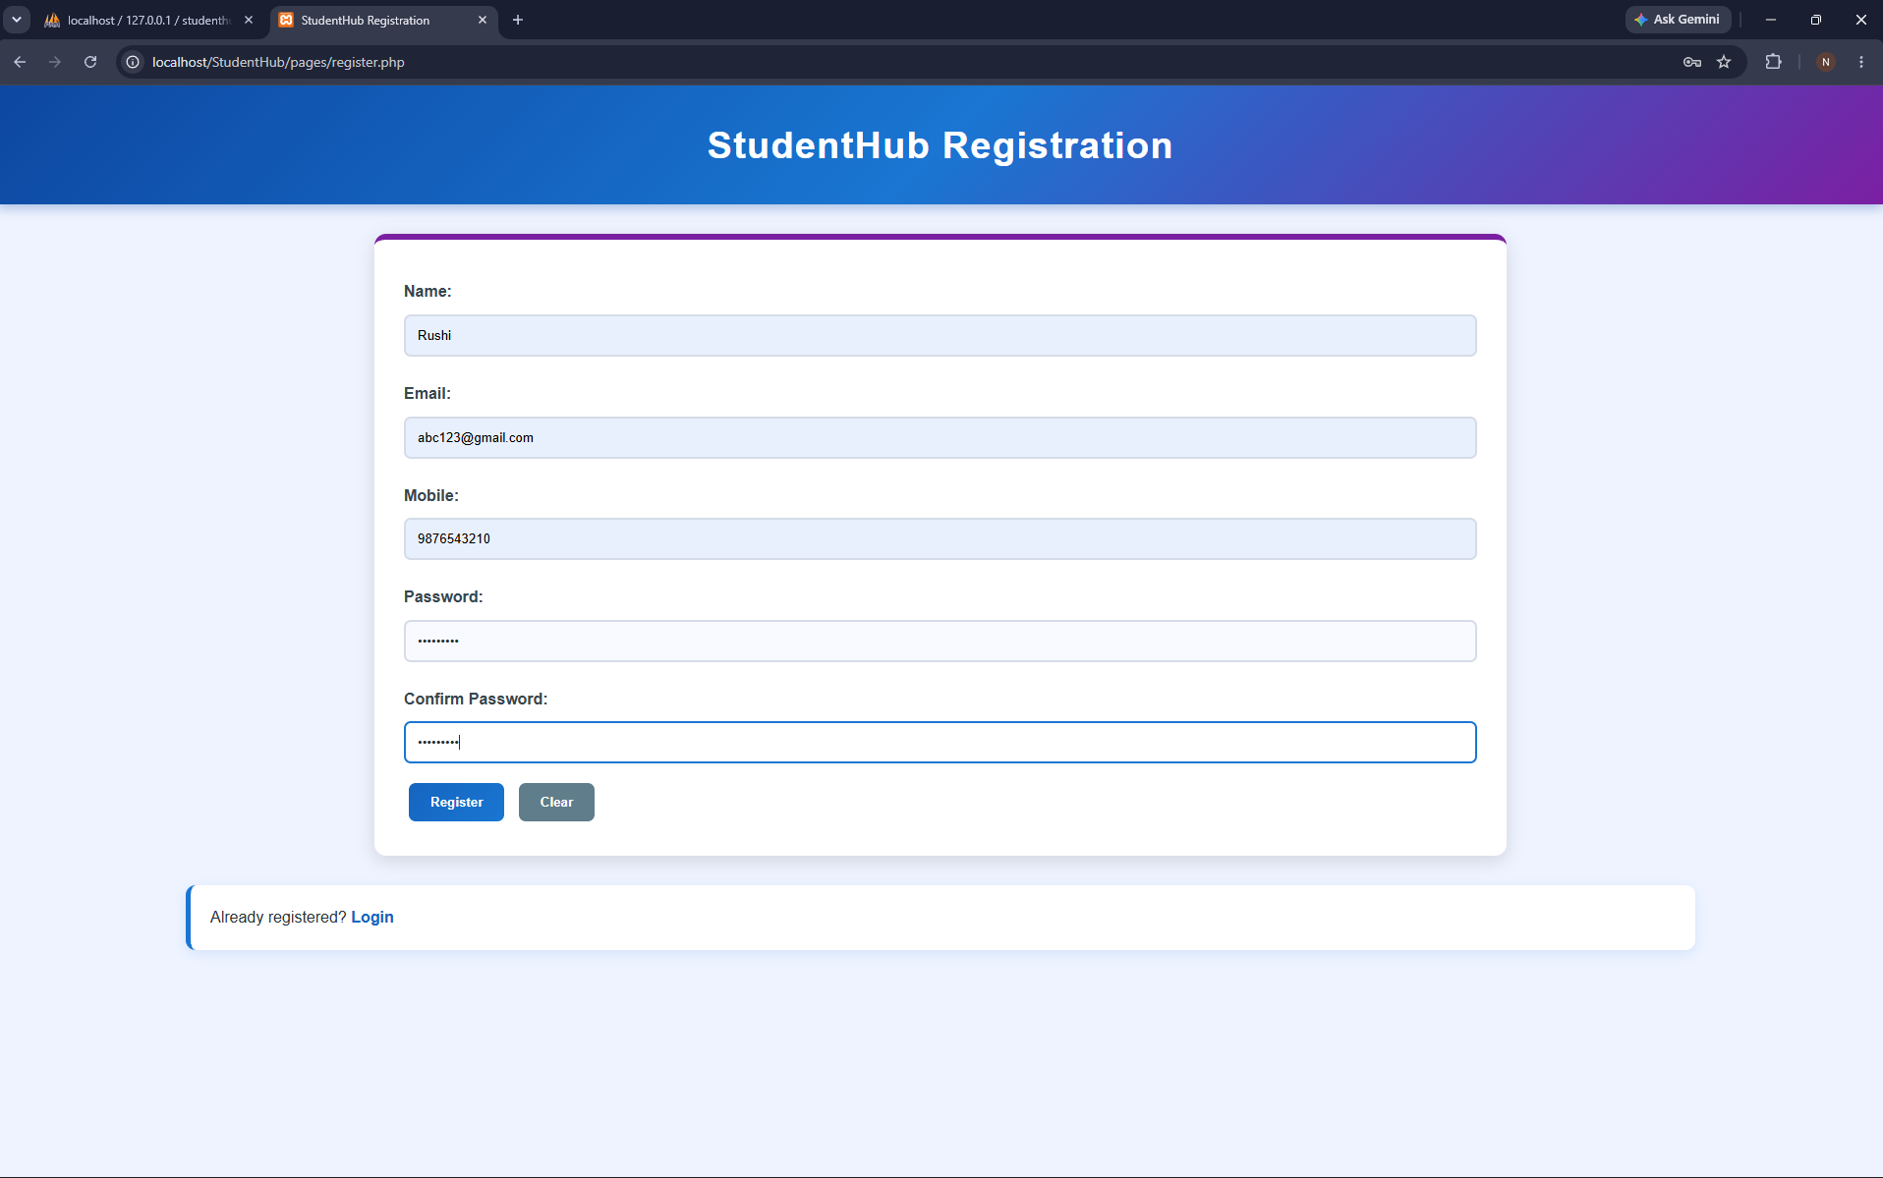
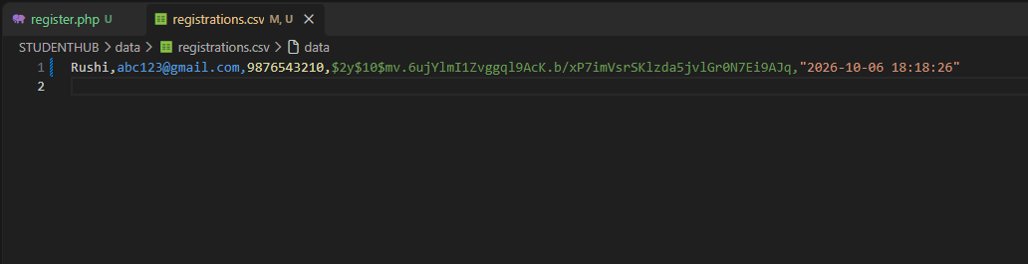

GitHub Repository Link:

https://github.com/rushiaghara25/StudentHub-Portal-2.git

Learning Outcomes:

Design a normalized MySQL database.

Create ER models with proper relationships.

Connect PHP to MySQL using PDO.

Use prepared statements for secure database operations.

Handle database errors securely.

Build secure database-backed web applications.

Faculty Remarks: (Keep this blank for faculty)

